**Experiment no. 3: To implement Binary Search for ‘n’ number and perform analysis using DAC technique.**

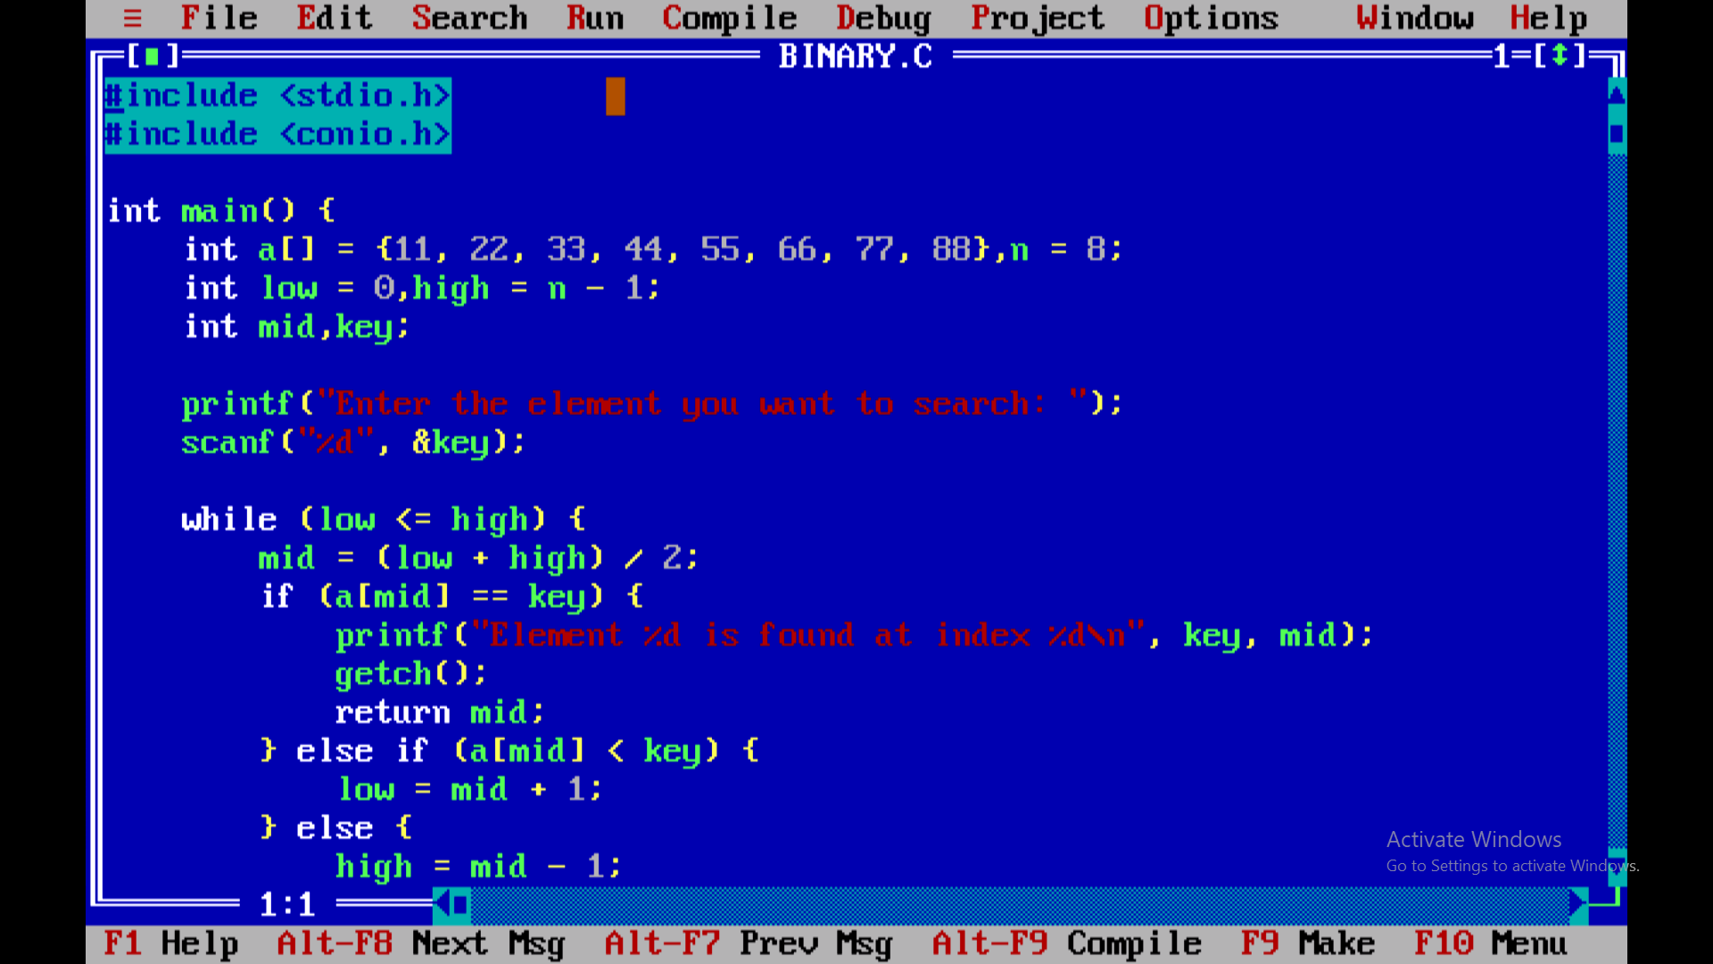

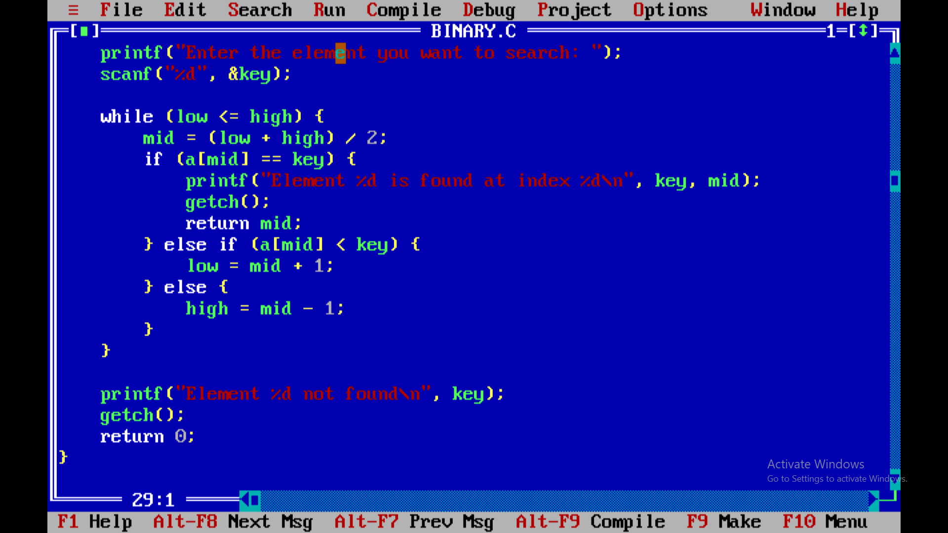

**Output:**

